MAP QUIZ: PRE-CONQUEST CULTURES
Latin American and Latina/o Art 111

DIRECTIONS: Draw on the map below the centers of the following civilizations: Olmec, Teotihuacan, Aztec, Toltec, Maya, Moche, and Inca. Write on the map or a separate sheet the approximate dates the civilizations are thought to have begun and ended.

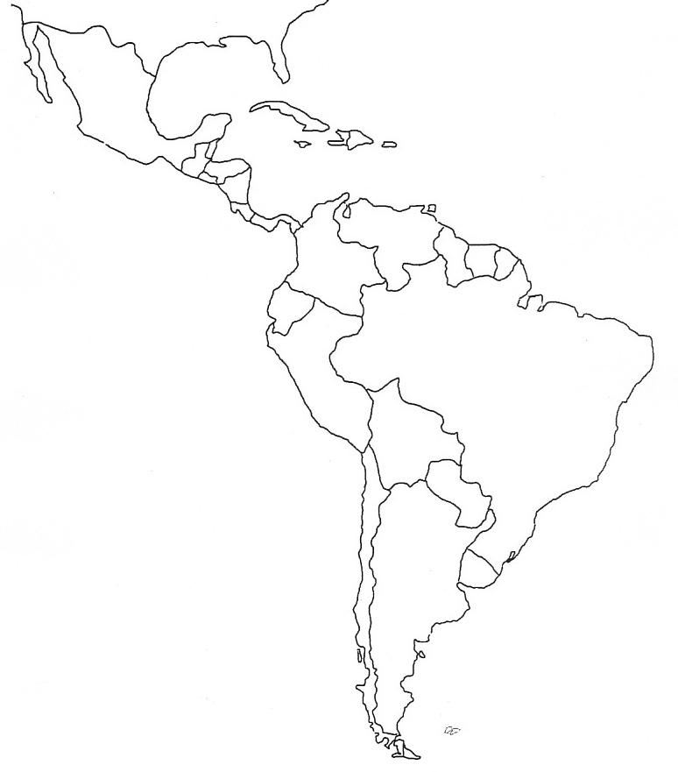
Your name ________________________________

